# Co-Op Scheduler Guide

Welcome! This documents how to use the co-op scheduler program.

## Key

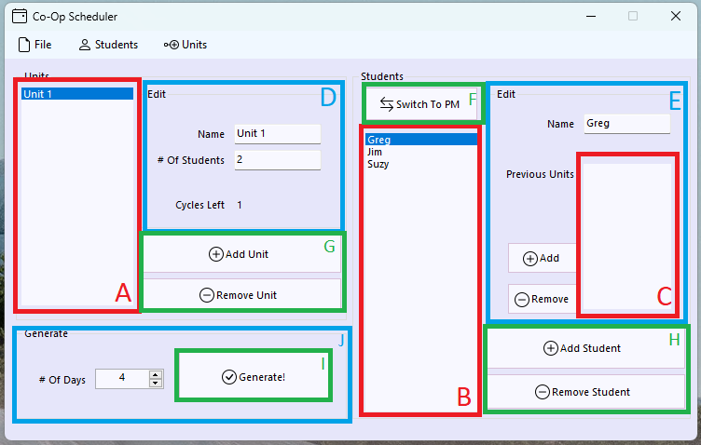

1. The Units List
2. The Students List
3. The Previous Units List
4. The Unit Editor
5. The Student Editor
6. The Switch Sessions Button
7. The Add/Remove Unit Buttons
8. The Add/Remove Student Buttons
9. The Generate Button
10. The Generate Form

## Adding Students

To add a student, click the “Add Student” button, then select the new student in the students list and edit their information.



Removing Students

To remove a student, select their name in the students list and click “Remove Student”



## Switching Sessions

To switch session, click the “Switch To AM”/”Switch To PM” button, this will change the students list to show students in the current session.



## Adding Units

To add a unit, click the “Add Unit” button, then select the new unit in the Units list and enter the information.



## Removing Units

To remove a unit, select the unit you want to remove in the units list, and then click “Remove Unit”



## Adding A Previous Unit for A Student

To add a previous unit for a student, first select the student’s name from the students list. Then, click on the unit you’d like to add in the units list. Finally, select “Add” next to the previous units list.



## Removing A Previous Unit for A Student

To remove a previous unit for a student, first select the student’s name from the students list. Then, click the unit you’d like to remove in the previous units list. Finally, click “Remove”



## Generating Schedules

To generate a new schedule, first enter the number of days you wish to generate for, then click generate. The program will take a moment to create a schedule and prompt you where to save it. After saving it, it will also ask you if you want to open it.

*See the attached video named “Generating.mp4” for a visual guide*

## Creating a table in Word

To create a table from the schedule in Word, first open the schedule file in notepad and copy everything. Then, paste it in word do Insert -> Table -> Convert Text To Table.

*See the attached video named “Word.mp4” for a visual guide*